|  |  |
| --- | --- |
|  | Name: Charlie Joseph  Date: 24/02/23 |
|  |  |
|  |  |

**Contents**

**Assignment Requirements**………………………………………………………………………………………………………….….2

* Cover page………………………………………………………………………………………………………………………….2
* Table of Content ………………………………….…………………………………………………………………………….2
* Main body…………………………………………………………….…………………………………………………………….3
* A reflective………………………………………………………………………………………………………………………….3

**First Task**

**Policies and Procedures**…………………….……………………………………………….……………………………3-5

**Second task**

Excel ……………………………………………………………………….…………………….…………………………….….5-6

The data………………………………………………………………………………….……………….………………….…7-11

**Third Task**……………………………………………………………………………….……………….….…………………………………….11-15

Tableau………………………………………………………………………….…………….…………………………………….16

**Main Body:**

**Reflective**: Enrolling into the Data Technician Boothcamp has enable me to be aware of tools that are used in data visualization and how these tools work. I was able to gain confidence in Excel, Tablue, Power BI working with data visulazion in the course. Going forward I can see my self employed or working with many of these tool to do data visualization.

**Excel:**

Working with Excel has given me the confidence of using other formula tools in excel to manipulate the date to make charts and graphy to represent my data. I was able to document step by step of what I did to get my date form raw data to visible data representation on charts and graphs.

**Tabluea:**

Working with Tabluea has given me the confidence of using the data to set relation to manipulate the date to make charts and graphy to represent my data. I was able to document step by step of what I did to get my date form raw data to visible data representation on charts and graphs in Tabluea. What went wrong was that after making many charts and graphs I thought that my Tablue was saved. However, I found out that my grapy was not saved when my computer shuts down and had to be restarted. I lost my data and had to redo all my graphs so I now ensure that every time I make a change I save the change.

**Assignment 1 Data Visualization**

**First Task**

**Policies and Procedures**

The policies need to be adhered to when working with data is the United Kingdom Data Protection Act of 2018. Link is below:

Outline what policies need to be adhered to when working with data. Below are the outlined policies quoted form “The Data Protection Act of 2018”.

<https://www.gov.uk/data-protection>:

# The Data Protection Act

The [Data Protection Act 2018](http://www.legislation.gov.uk/ukpga/2018/12/contents/enacted) controls how your personal information is used by organisations, businesses or the government.

The Data Protection Act 2018 is the UK’s implementation of the General Data Protection Regulation (GDPR).

Everyone responsible for using personal data has to follow strict rules called ‘data protection principles’. They must make sure the information is:

* used fairly, lawfully and transparently
* used for specified, explicit purposes
* used in a way that is adequate, relevant and limited to only what is necessary
* accurate and, where necessary, kept up to date
* kept for no longer than is necessary
* handled in a way that ensures appropriate security, including protection against unlawful or unauthorised processing, access, loss, destruction or damage

There is stronger legal protection for more sensitive information, such as:

* race
* ethnic background
* political opinions
* religious beliefs
* trade union membership
* genetics
* biometrics (where used for identification)
* health
* sex life or orientation

There are separate safeguards for personal data relating to criminal convictions and offences.

## Your rights

Under the Data Protection Act 2018, you have the right to find out what information the government and other organisations store about you. These include the right to:

* be informed about how your data is being used
* access personal data
* have incorrect data updated
* have data erased
* stop or restrict the processing of your data
* data portability (allowing you to get and reuse your data for different services)
* object to how your data is processed in certain circumstances

You also have rights when an organisation is using your personal data for:

* automated decision-making processes (without human involvement)
* profiling, for example to predict your behaviour or interests

Reference: <https://www.gov.uk/data-protection>

# **Second task**

## **Excel**

I worked with ‘The Wealth of nations’ data which is in the week five folder under day 1 – student resources

<https://justit831.sharepoint.com/:x:/s/DataAnalyticsProgramme-NewStandards/EVK1dsCfWvZMpvJzG9QaQk8B1nxx7hYR0KtGfbzJauf94g?e=CR1LFE>

**GDP Tasks**

1. I set a password to protect the workbook

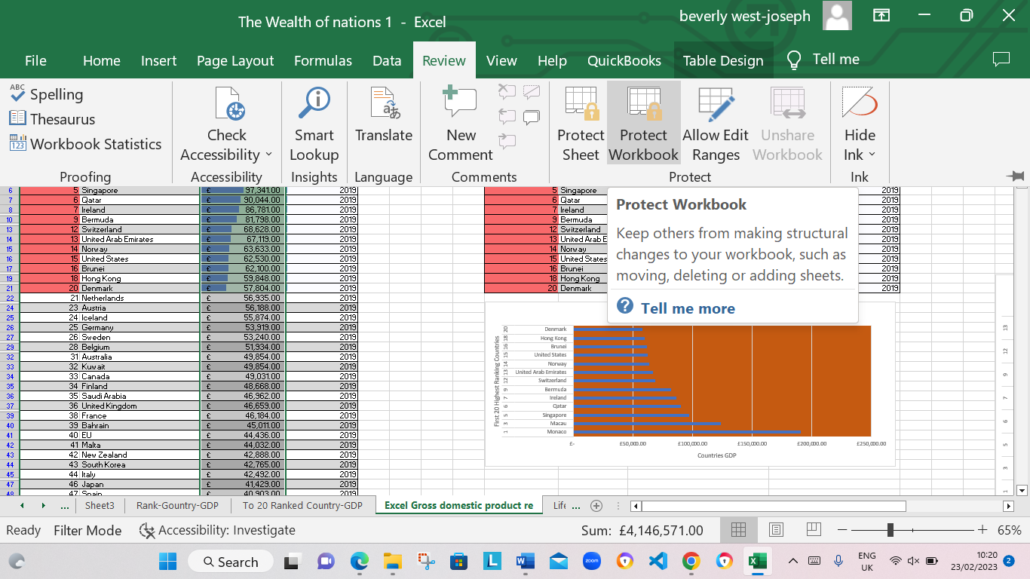

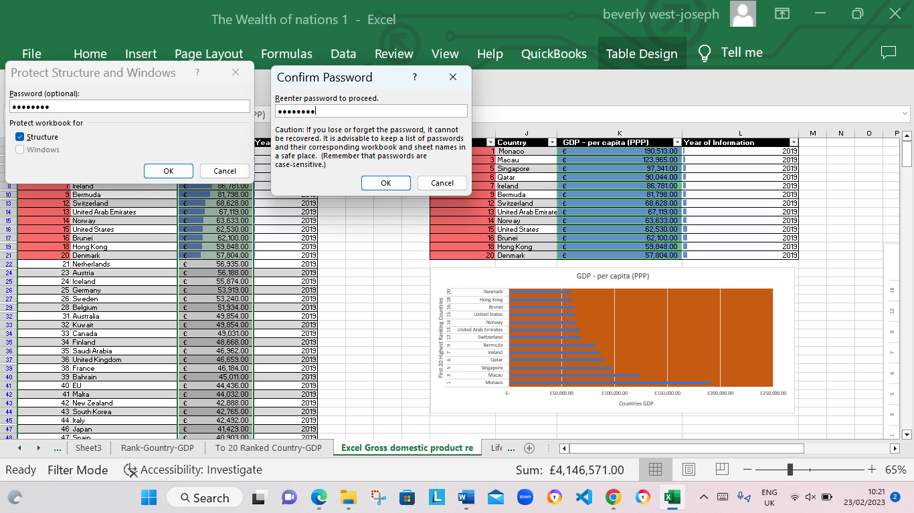

1. I highlighted column C and change the data to display in British Pound symbol

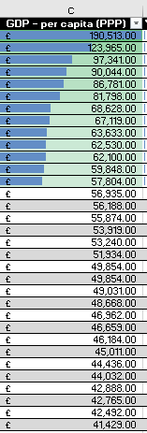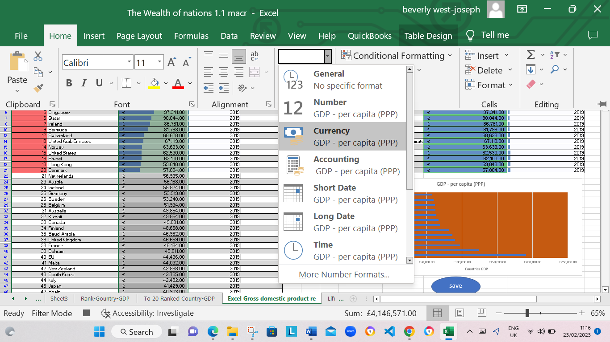

1. I turned the GDP sheet into a table.

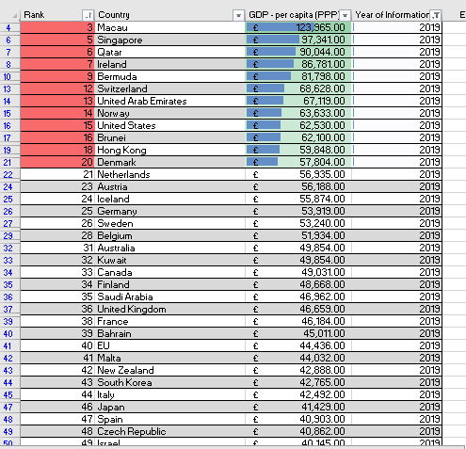

1. I filtered the table to display only the information for 2019

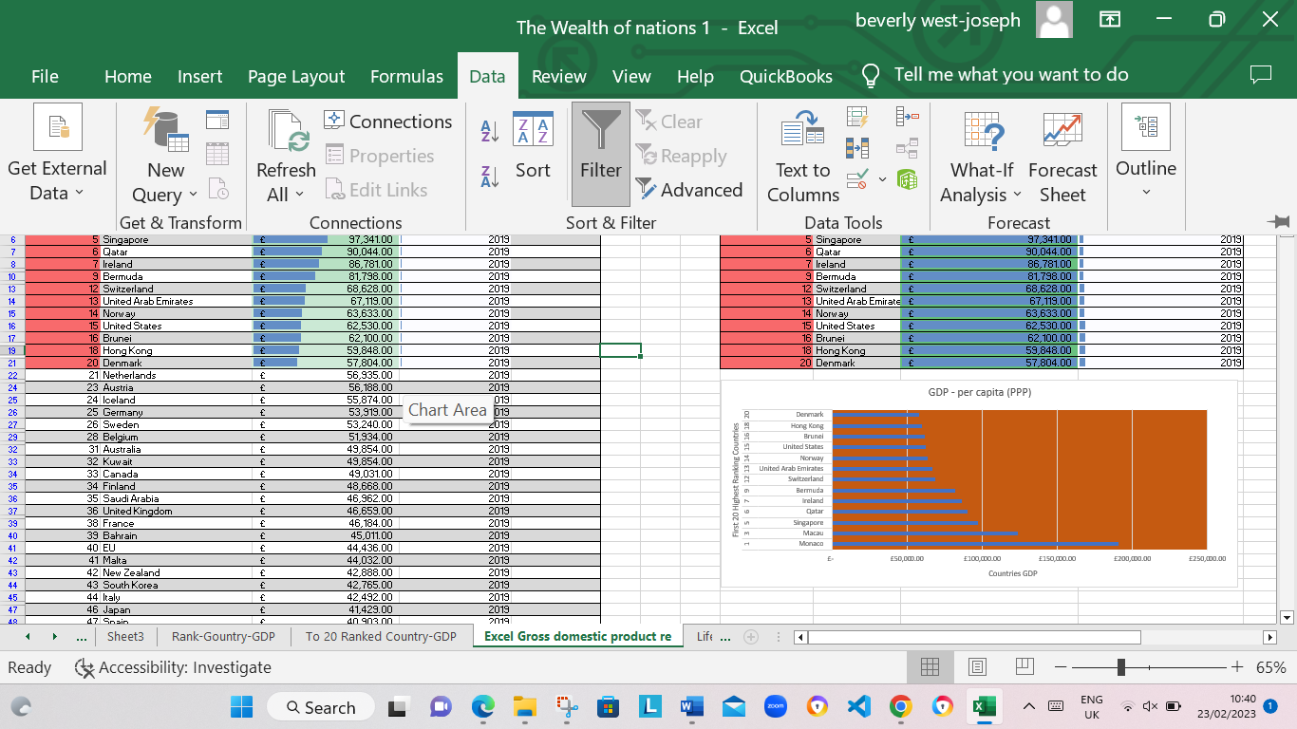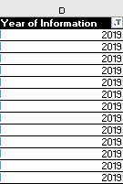

1. I created a chart that will only display the following data ‘Rank, Country and GDP - per capita (PPP). The chart can be anything as long as it is suitable.

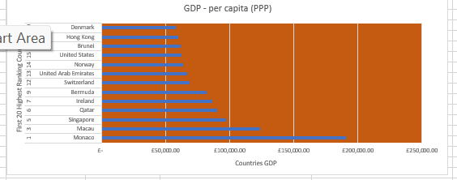

1. Using my creative skills, I edited the chart
   1. I added a title
   2. I added X and Y axis labels
   3. I made the chart visually pleasing



1. I moved the chart to a new sheet tab and label with a suitable name “Top 20 Ranked Country-GDP”

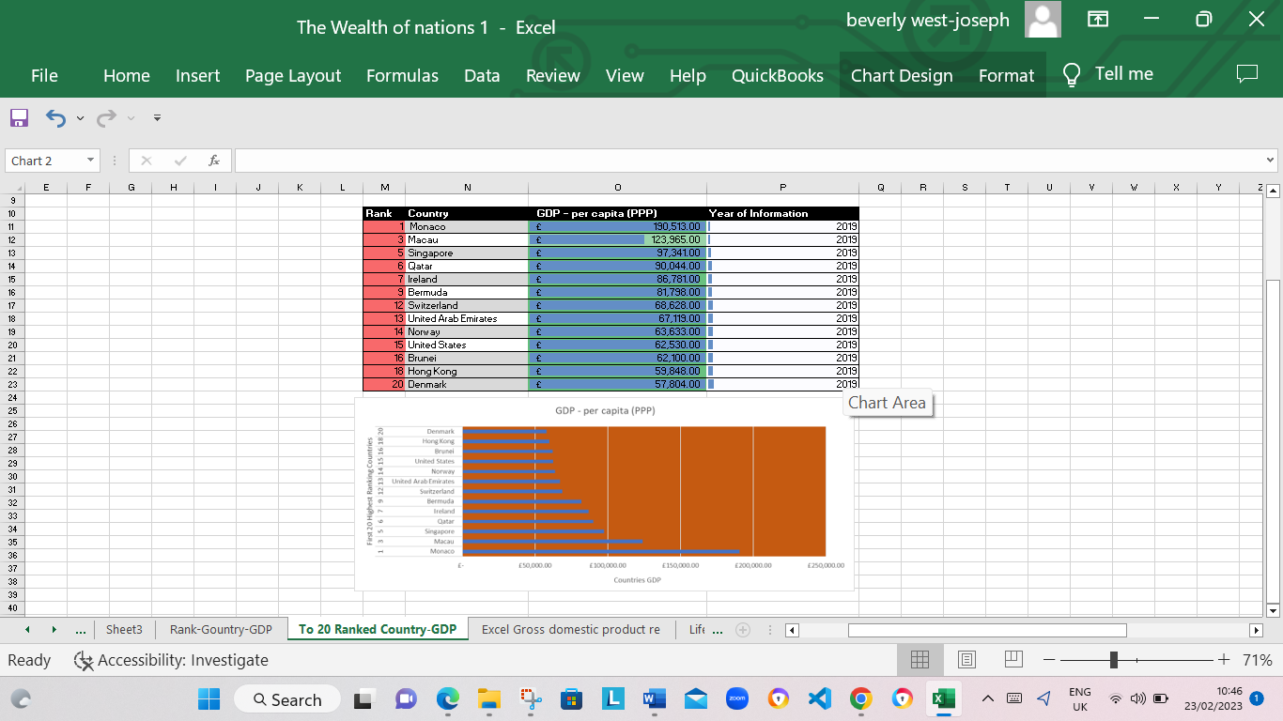

1. I created a sort for the top 20 highest ranking counties

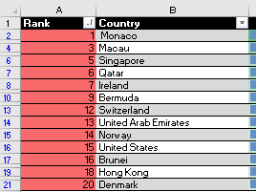

1. I then created a new Bar chart to display the 20 highest ranking countries from your sort and then move the chart to be underneath the table, as shown below.

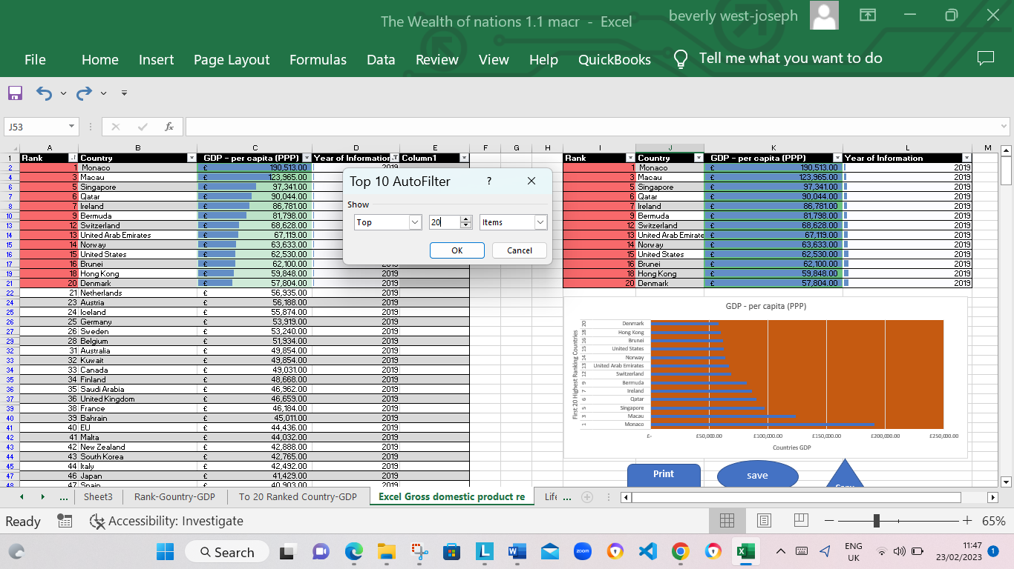

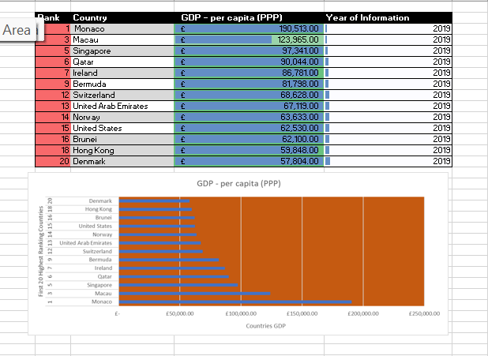

1. I coloured the background by highlighting the area underneath the table as shown below. Find the add a fill colour icon and sellected a colour.



1. I then created 3 macro buttons, print the sheet, Save the file and Copy the sheet.

I copied the sheet in a macro you hightlight the area to be copyed then right click copy then stop the macro. Next I asigned the macro to the copied button.

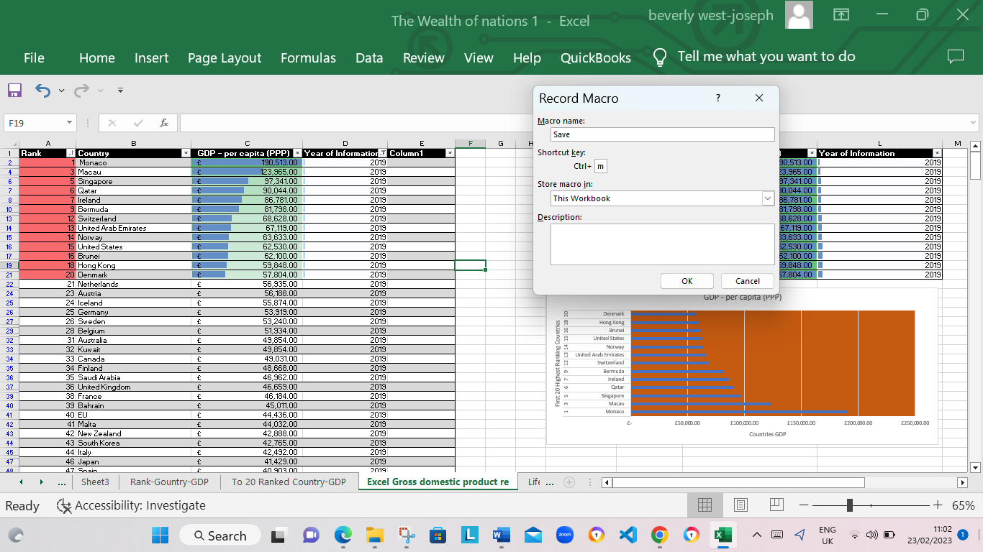

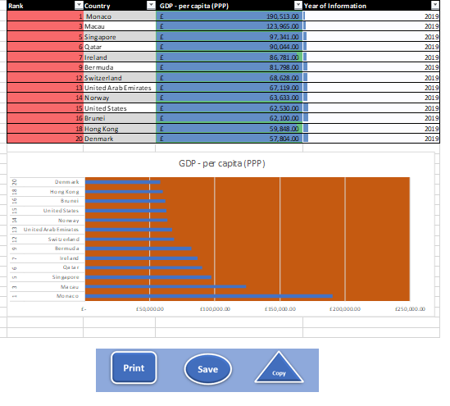

1. Using the copy macro, I coped the sheet and then paste it into a new word document keeping the formating, and gave the page a title ‘GDP (Gross domestic product)’ .
2. I Saved my document as ‘Word Gross domestic product report 1’

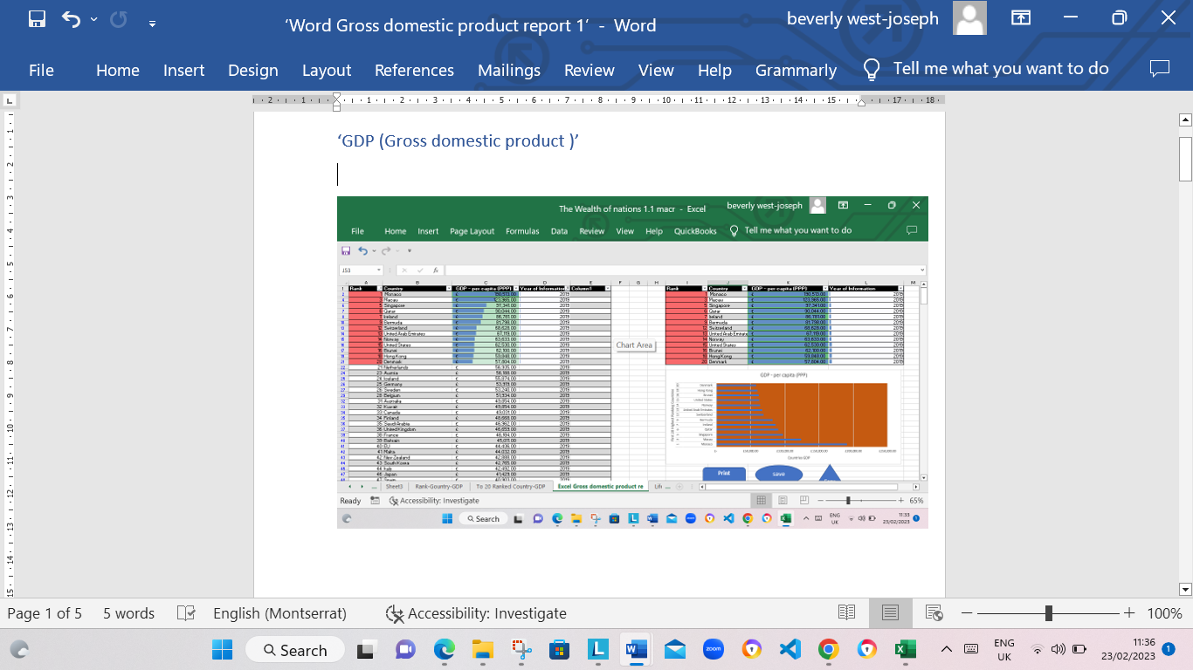

1. I added a headder and footer to our table.I selected the ‘View’ tab from the top and find the ‘workbook views’ area, as seen below:

* Then I selected the ‘Page Layout’ icon . This then displayed the screen with a header and footer as seen below. I enter my information into the three boxes.

1. In the header, I entered my name and GLA DATA 1 in the three boxes

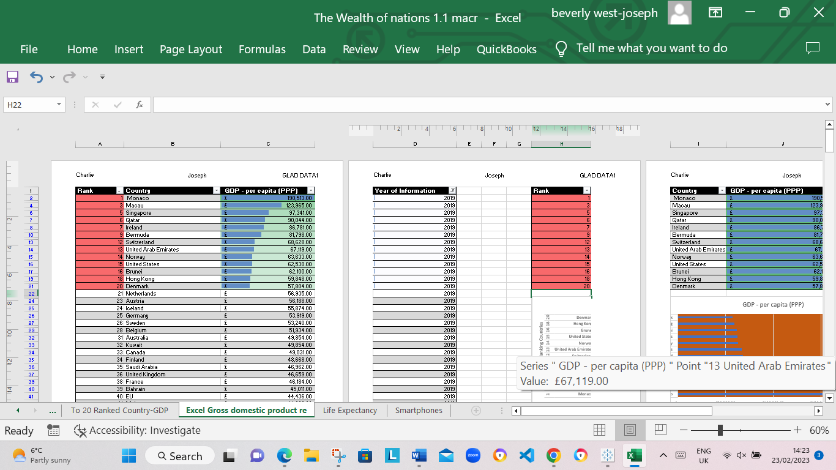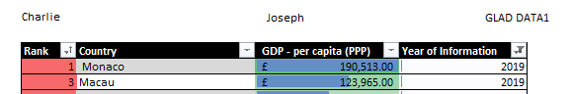

1. In the footer I added todays date then Assignment 1 and lastly Data Visualisation.



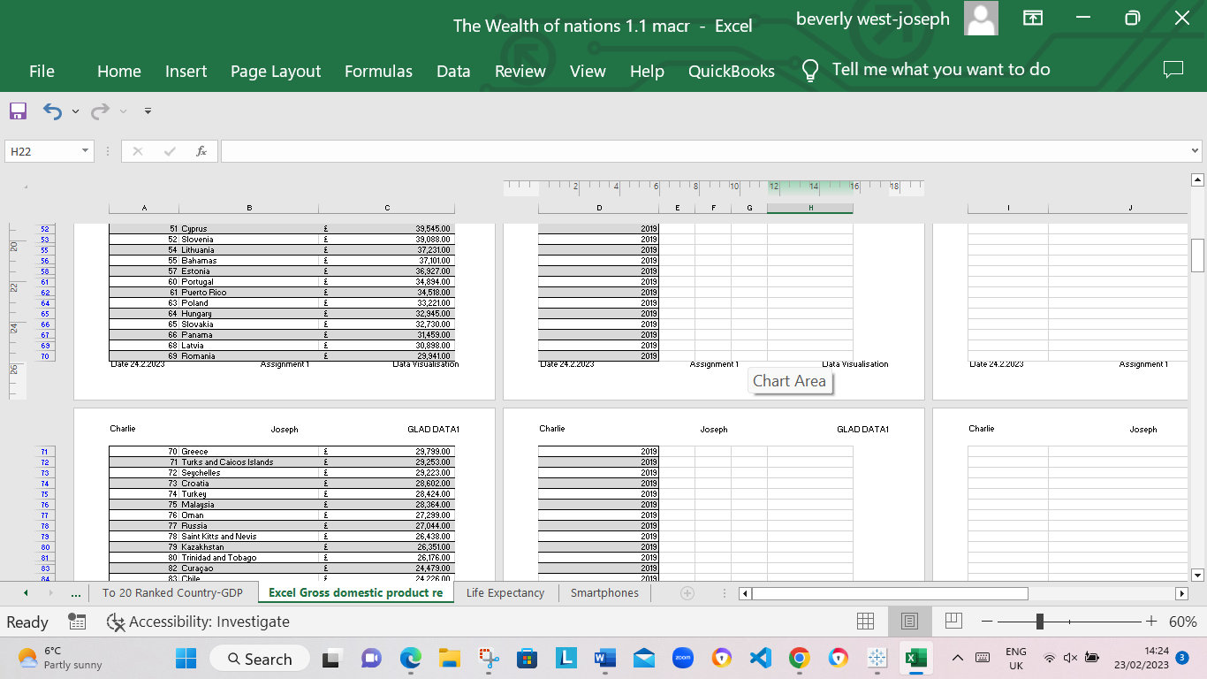

1. I returned my view to normal

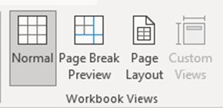

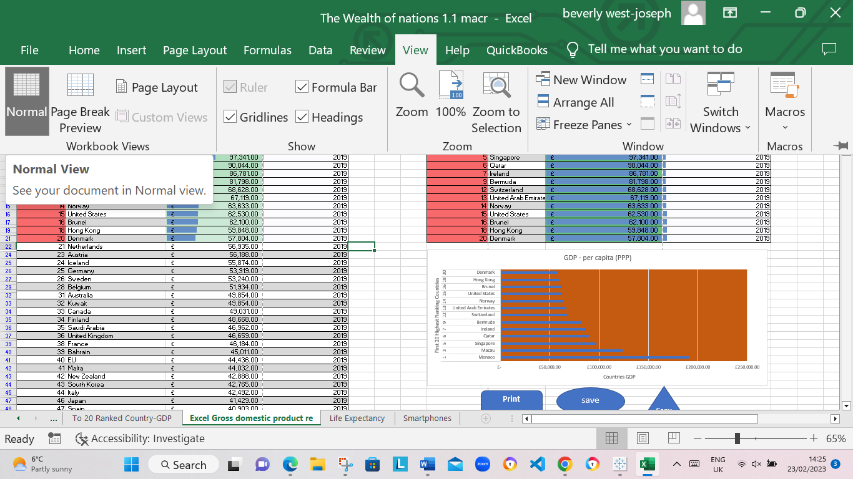

1. I saved my table as ‘Excel Gross domestic product report 1’

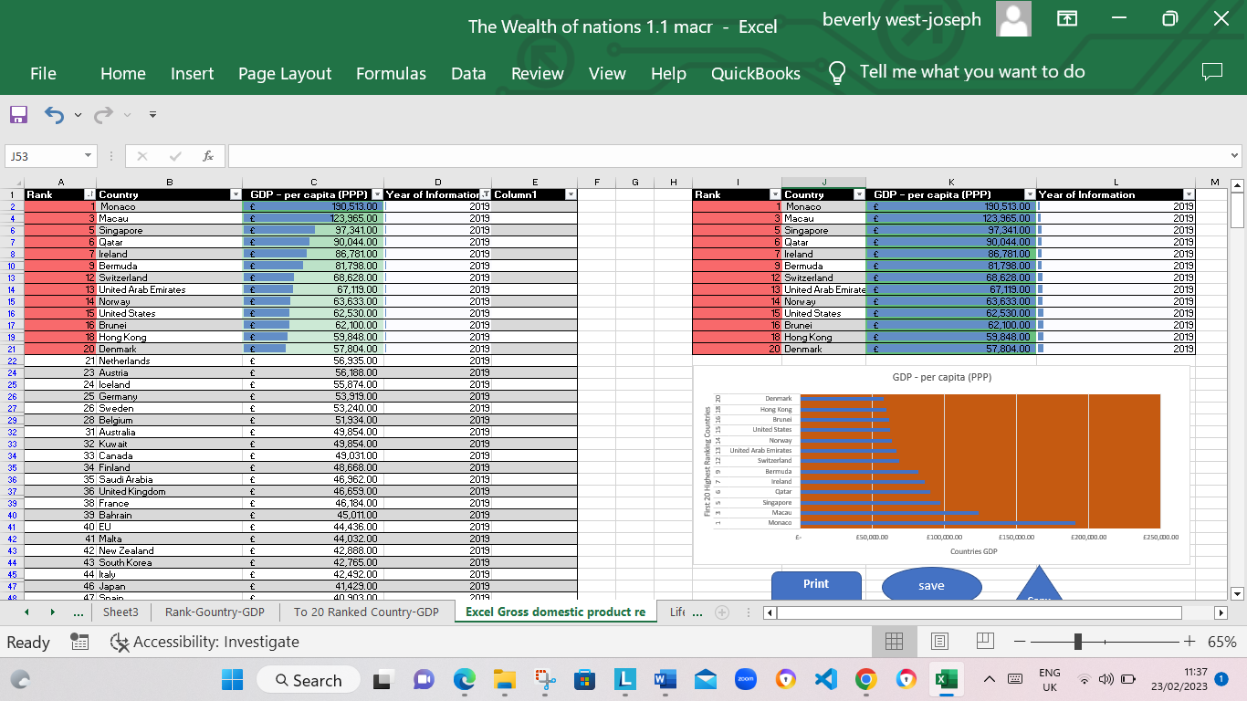

1. I closed my word document only.

**Third Task**

I continued working with the Excel table ‘The Wealth of nations’

**Tableau**

I opened ‘The Wealth of nations’ data from:

<https://justit831.sharepoint.com/:x:/s/DataAnalyticsProgramme-NewStandards/EVK1dsCfWvZMpvJzG9QaQk8B1nxx7hYR0KtGfbzJauf94g?e=CR1LFE>

I followed the workflow that we used in the workshop, as seen below:

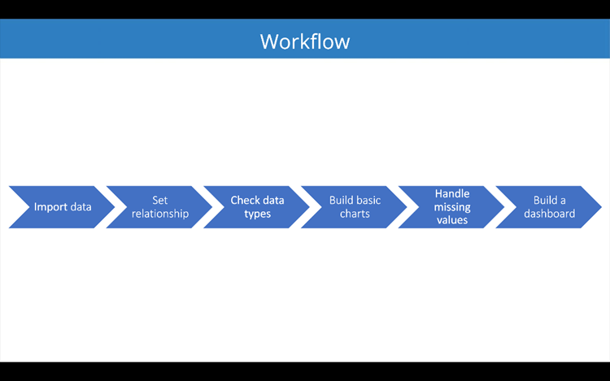

1. I imported data

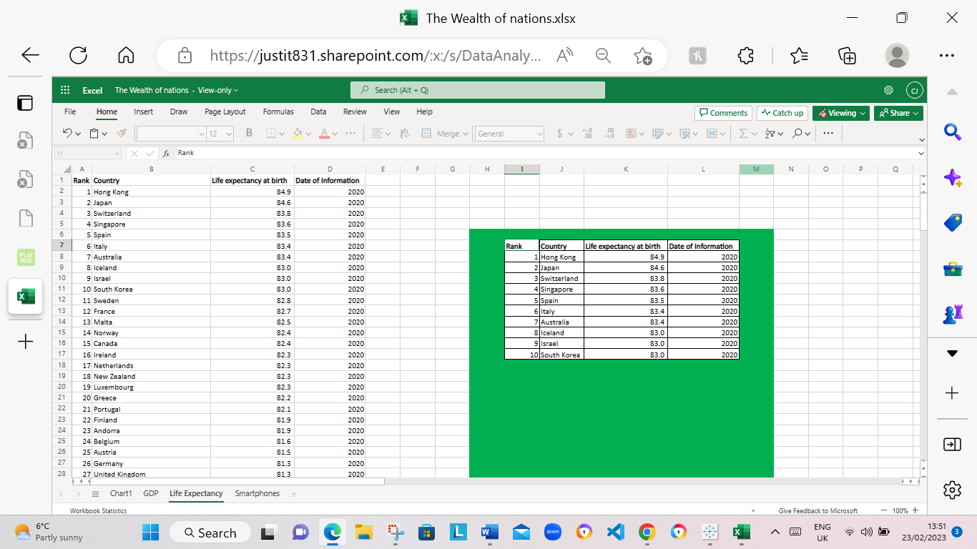

1. I set relationships:

I had three sheets and the common column for all of them is country, so the visual arrangement of the sheets does not matter Only the columns that I used to create the relationship matters. I arranged the sheets in a straight line as seen below: The relationship was set to country since that the common relation in all tree data sets.

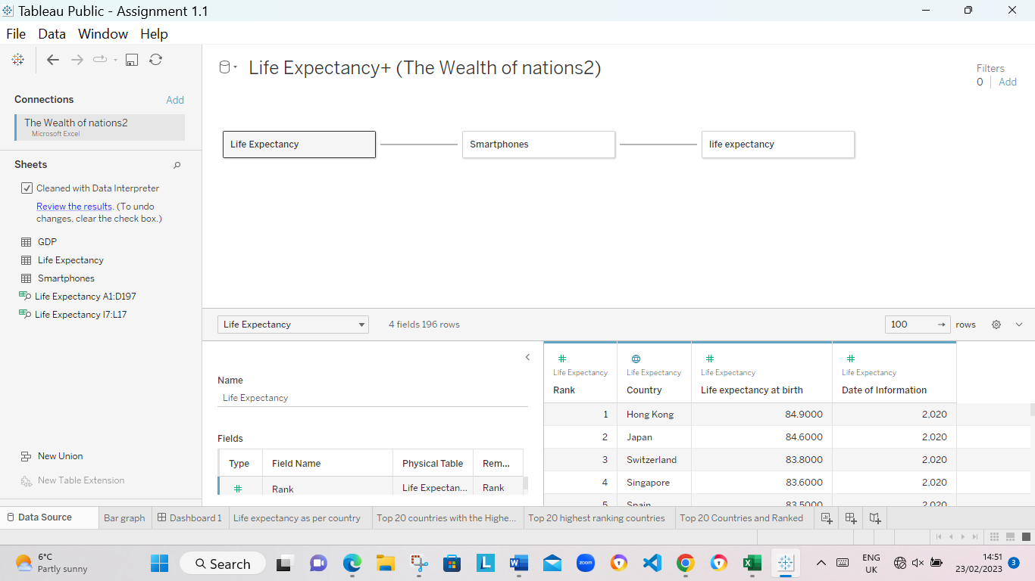

1. I checked the data types, after the data types were checked and verified with the relationships set.
2. I started to build my charts
3. As I created my charts, the little grey box that containing a count of null values, was filtered.
4. I built my dashboard.

I created 4 visuals charts according to clients’ requirements.

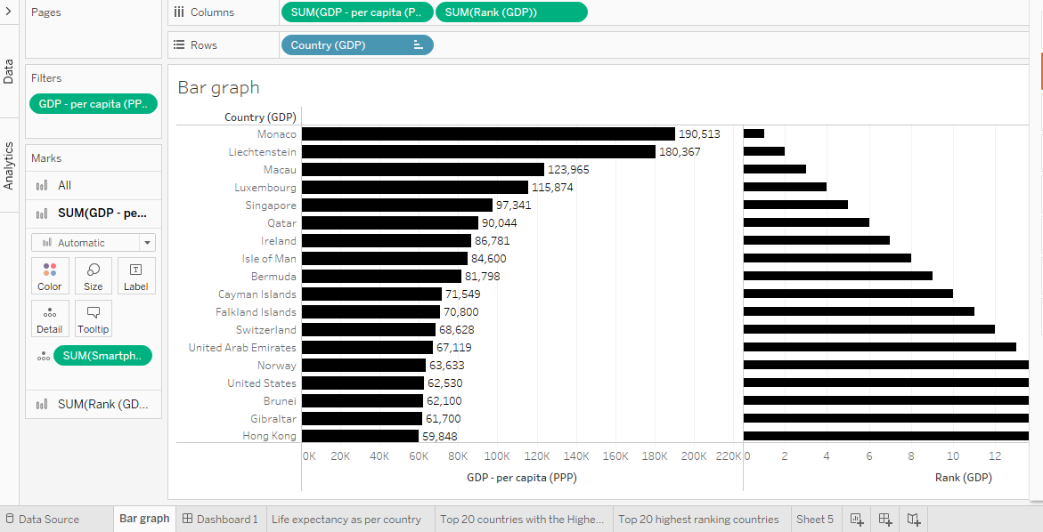

Top Rank 20 Countries and their GDP.

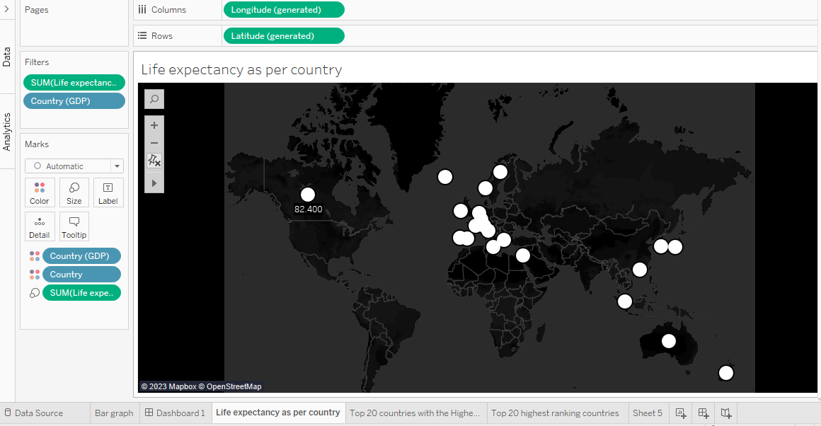

Top 20 Countries and their life expectancy.

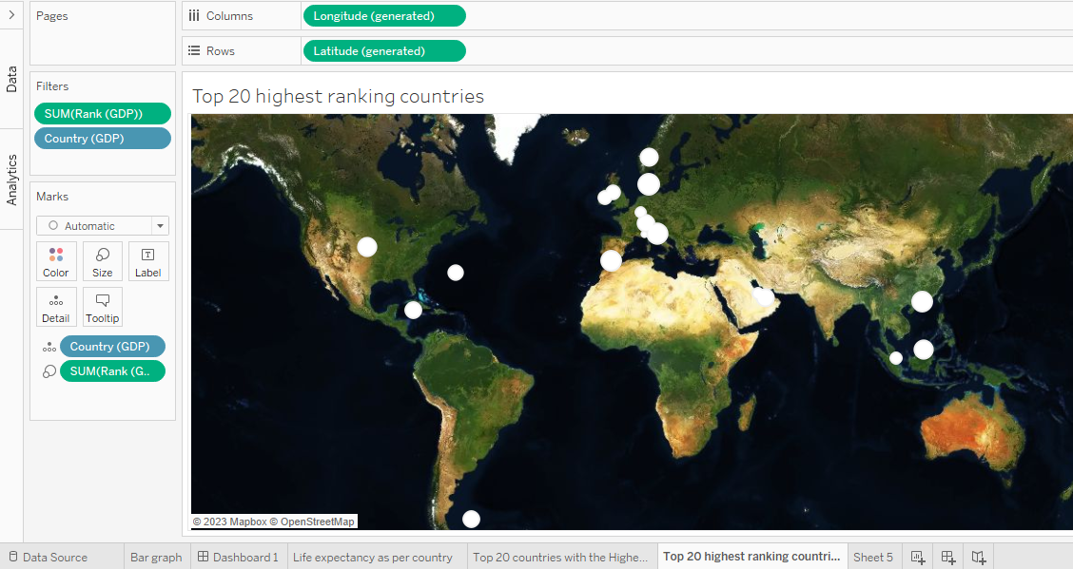

Top ranked 20 Countries and locations

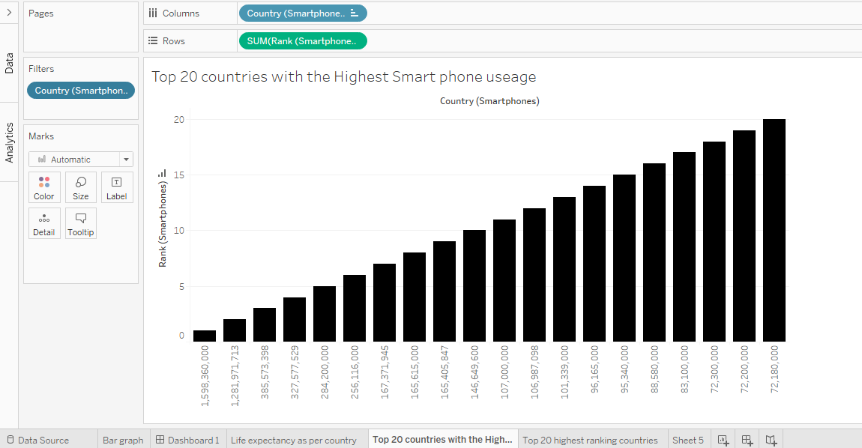

Top 20 countries with the highest Smart phone usages

**My Dashboard** displaying top 20 countries with the highest ranked and GDP, top 20 countries location, top 20 countries that uses the most smartphone s and the life expectancy of the top 20 countries.

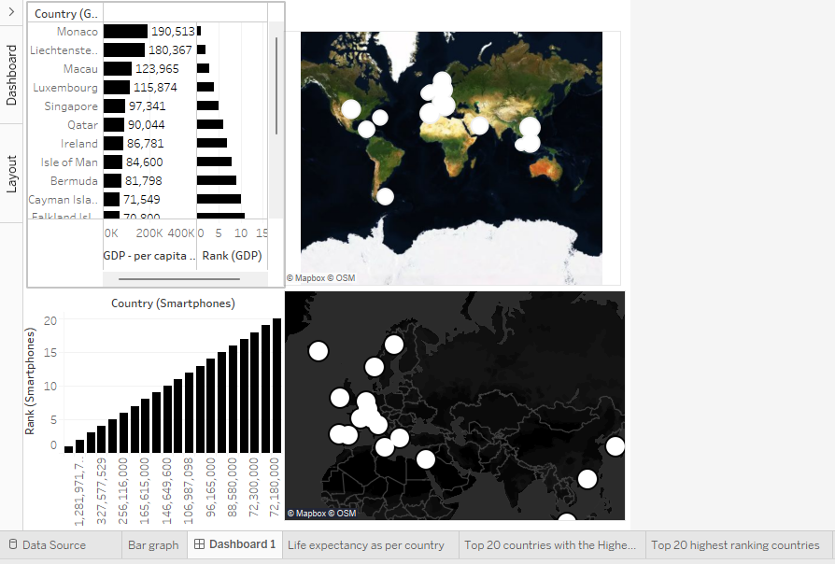

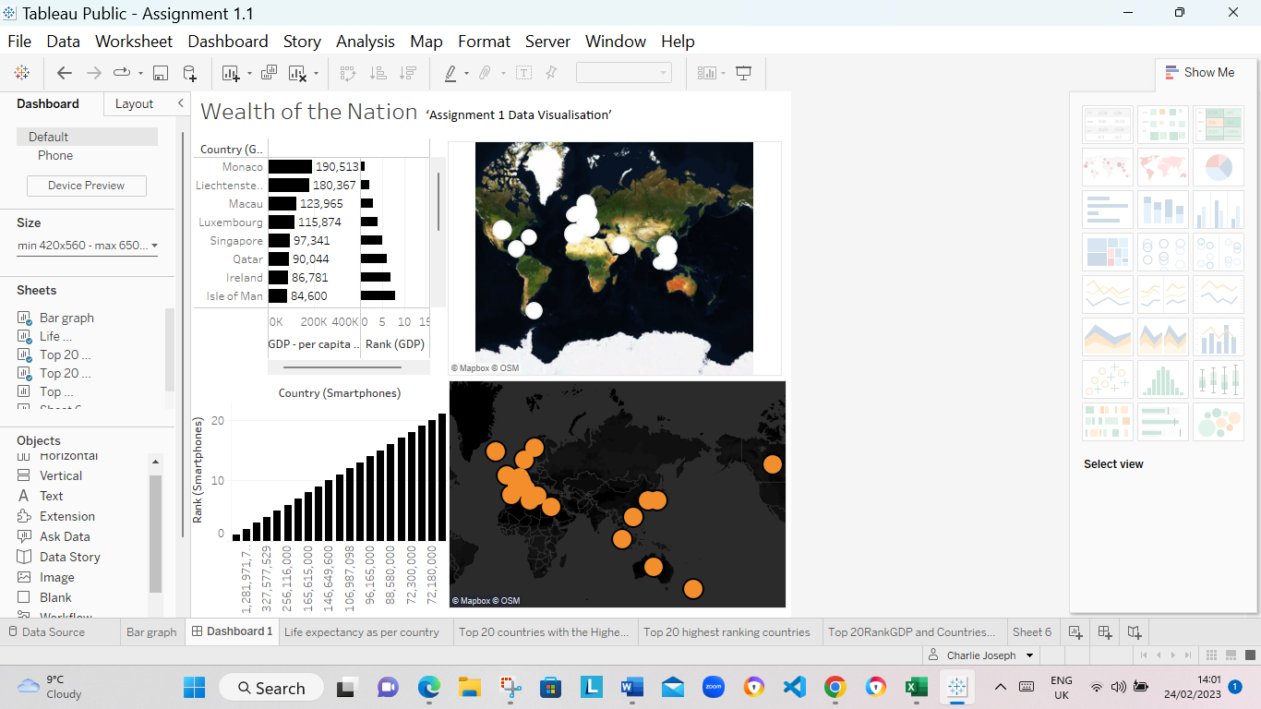

[Assignment 1.1 | Tableau Public](https://public.tableau.com/app/profile/charlie.joseph/viz/Assignment1_1_16763711218330/Dashboard1?publish=yes)

I save my file as ‘Assignment 1 Data Visualisation’

A copy was emailed to [amandaw@JustIT.co.uk](mailto:amandaw@JustIT.co.uk) or [Vinitas@JustIT.co.uk](mailto:Vinitas@JustIT.co.uk).